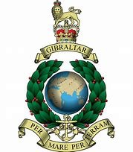

42 Commando Association Application Form
Please enrol me as a FULL/HONORARY member of 42 Commando Association.
I enclose the membership donation of £5.00 (Annual donation), Cheques made out to 42 Commando Association.

Name……………………………………………………………………………………………………

Address……………………………………………………………………………………………….
……………………………………………………………………………………………………………
……………………………………………………………………………………………………………
Tel/Mobile number…………………………………………………………………………….
Email Address………………………………………………………………………………………
My Service Details Are.
Regimental Number…………………………………………………………………………….
Squad/Troop…………………………………. Enlistment Date………………………
Service with 42 Commando From……………………. To……………………………
Service with other Royal Marines Units……………………………………………….
Service with other armed forces. Unit……………………. From…….To……….

Please return to the secretary
Frank Needham
93 Windsor St
Wolverton
Milton Keynes
MK12 5AN

Service with 42 Commando = Full Membership

Service with other Royal Marine or Armed Forces units = Honorary membership

